

**duPont Manual High School**

**Class of 2024!**

**Important Documents to View:**

* Scheduling Video or PowerPoint
* Complete the Google Course Request Form
* Athletic Department Information
* YPAS Audition Information
* Subscribe to Manual Social Media Sites

Welcome to Manual High School. We are so proud of your accomplishments thus far and look forward to celebrating the many milestones to come. In order to prepare for your freshman year there are several items that need to be addressed.

PARENT PORTAL:

Log onto: [www.jcpsky.net](http://www.jcpsky.net)

Click on: Parents

Click on: Parent Portal

Follow account set-up instructions

Check email

HIGH SCHOOL PERMANENT RECORD:

* Copy of certified birth certificate.
* Copy of social security card (used to coordinate KEES scholarship money.
* Copy of current Kentucky immunization certificate with expiration date. Certificate must include HepA and Meningococcal vaccines.
* Your student’s records will be requested from their Middle School. However, the documents listed above are not included with private, parochial or out of state records.
* All incoming students enrolling at Manual from a private, parochial or out of state school will need to provide these documents to the Manual Guidance Office.
* Anita Sanders, Records Clerk/Registrar (502) 485-8503. Records can also be uploaded and emailed to the following email address: [anita.sanders@jefferson.kyschools.us](mailto:Anita.sanders@jefferson.kyschools.us).

**Counselors:**

Marti Johnston

[marti.johnston@jefferson.kyschools.us](mailto:marti.johnston@jefferson.kyschools.us)

Michelle Leslie

[michelle.leslie@jefferson.kyschools.us](mailto:michelle.leslie@jefferson.kyschools.us)

Amy Medley

[amy.medley@jefferson.kyschools.us](mailto:amy.medley@jefferson.kyschools.us)

Amy Meeron

[amy.meeron@jefferson.kyschools.us](mailto:amy.meeron@jefferson.kyschools.us)

Kevin Fowler – all YPAS

[kevin.fowler@Jefferson.kyschools.us](mailto:kevin.fowler@Jefferson.kyschools.us)

Counseling Website:

[www.dupontmanualcounseling.com](http://www.dupontmanualcounseling.com)

Counseling Twitter:

@dmhsguidance

Manual Athletics:

@ManualAthletics

duPont Manual Website:

[www.dupontmanual.com](http://www.dupontmanual.com)

duPont Manual Twitter:

@duPontManual

Subscribe to Manual POST

e-newsletter:

Bit.ly/POSTSubscribe

J&C News:

Manualredeye.com

Contact the PTSA:

[Manualptsa@gmail.com](mailto:Manualptsa@gmail.com)

Manual PTSA:

@manualptsa

facebook.com/groups/ManualPTSA



Summer Reading Suggestion: (From 9th Grade English Teachers)

For recommended reading, rising freshmen intending to take Advanced English may want to read some Greek mythology. It creates a little context for The Odyssey.

Note: If you want to be considered for the AP Seminar (English 2) course during your sophomore year – you must take Advance Program (ADV) English 1 as a prerequisite.



**For Level 2 Spanish, a student should be able to:**

* State name, age, and address
* Describe their physical appearance
* Express which sports and activities they like and dislike
* State their favorite foods and drinks and those they do not like
* Identify their classes and when they meet
* Describe aspects of daily life, including friends, family, school
* Speak about familiar activities
* Speak about other’s free time activities, like, and dislikes
* Present biographical information about others
* Provide basic instructions about how to make or do something

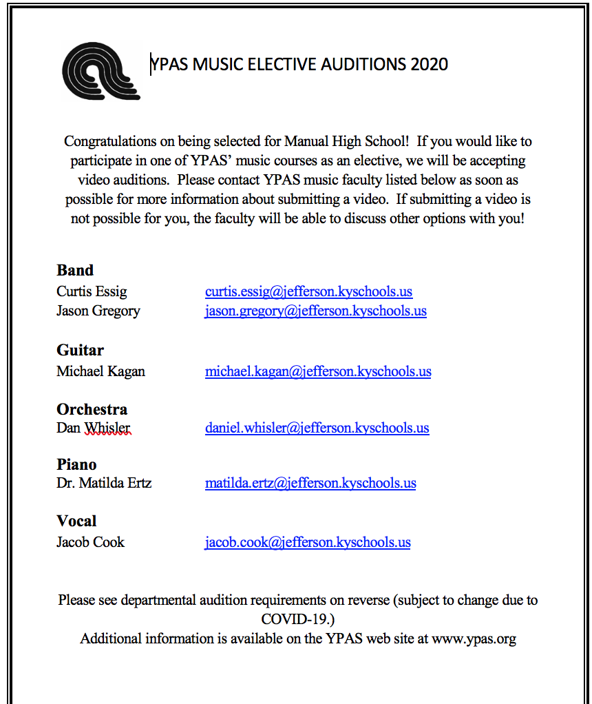

**VA REMINDER:**

By 2nd week of school:

• 1 Masonite drawing board, at least 22”x25”

• 1 red fiber portfolio, at least 20”x26”

• 1 plastic art bin tool box to carry supplies—12 or 14”x6” to 8”x6”to 8” (can be a tackle box)



**J&C UPDATES:**

Please ask your parents/

guardians to join the J&C

email list. They can join by emailing

Mr. James Miller at [james.miller@jefferson.kyschools.us](mailto:james.miller@jefferson.kyschools.us).

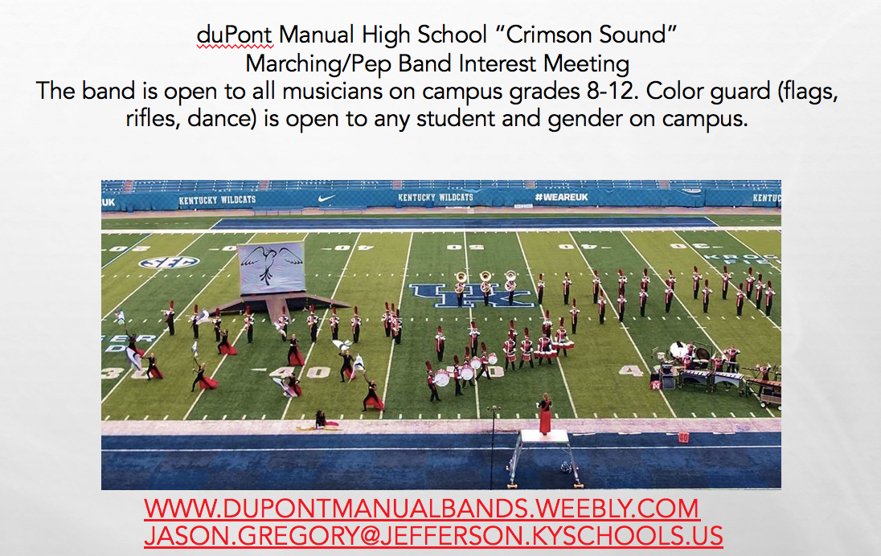

**MST UPDATES:**

Visit the MST Website:

<https://www.dupontmanualmst.org/>